 | Vol. xx, No. x (202x) x-x, doi:  Proceedings on Engineering  Sciences  www.pesjournal.net | 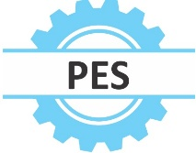

Enhanced Accuracy and Customization in Hand Gesture Cursor Control Using Python and OpenCV

KAMALANABAN E
V.SABAPATHI
NAVEEN N
LATHISH P
NIHITHA T
Keywords:  Hand Gesture Recognition, Cursor Control, Human Computer Interaction (HCI), Computer Vision, Real Time Processing, Gesture Customization | A B S T R A C T
Recognition of hand gestures has been crucial in modern applications and thus its improvement is an essential issue. The issues remain, such as the improvement of recognition accuracy and speed. Therefore approaches solely based on hand gestures were developed to provide a smoother interaction experience. This paper describes a system that intends to make the control of the mouse by hand movements both more natural and efficient human computer interaction. Using a webcam, this system captures video feeds and uses Python libraries like PyAutoGUI, Numpy, and OpenCV for image processing and gesture recognition. It spots fingers painted movements to perform mouse cursor actions such as movement, click, drag and scroll. The system enhances the speed and accuracy of cursor movement using sophisticated algorithms and optimizations such as increased frame rates and predictive tracking. This research proves the fact that taking into consideration only hand gestures the proposed system offers a highly intuitive, efficient, and even more reliable method of interaction between humans and computers, which makes it useful for many applications in professional presentations, as in watching movies or playing computer games, and so many other applications, which significantly enhance user convenience and engagement.

© 2025 Published by Faculty of Engineering


- INTRODUCTION
Recent advancements in hand gesture recognition technology have significantly improved human computer interaction by enabling the user to control the computer system through hand movements naturally and intuitively. This paper presents a novel mouse simulation system designed to exploit these advances. It captures video from a webcam and translates specific hand gestures into actions such as cursor movement, left click, right click, dragging, selecting, and scrolling through predefined gestures involving three colored fingers. we are sitting in a presentation, one does not have to move around to the podium to select an application. This solution is practical and convenient when the situation arises. It is also designed to integrate image processing, from which it extracts all necessary data, and interacts with the computer's mouse controls. The system was coded in Python, relying on the OpenCV library for image processing and PyAutoGUI to simulate mouse actions.

Over the last decade there has been much growth in hand gesture recognition technology (Damaneh et al(2023)). This technology has transformed human computer interaction since it allows users to use computer systems through intuitive and natural hand gestures. The processes involved in hand gesture recognition include image capture hand detection hand extraction and gesture classification (Wu et al(2023) & Fayyaz et al (2023)). These processes are becoming increasingly user friendly for user ensuring they interact with computers and other devices very conveniently. There are several hand gesture recognition methods including glove based and LED based techniques (Lin et al (2022) & Singh & Chaturvedi(2022)). However, the naturalness of human computer interaction is often disrupted because such methods require external devices (Bi et al(2023)). Due to this researcher developed methods of controlling computer functions using only hand gestures as a result the interaction is even more natural (Jiang et al(2023)). It finds great practical use in a plethora of fields like gaming and virtual reality health sectors and even educational facilities (Maskeliūnas et al(2023)). In medical research this can allow a surgeon to handle any necessary medical equipment by making use of hand gestures and completely prevent physical handling and potential infections. Using this sort of hand gesture recognition in education teaching aids have been created to improve effective learning and engagement levels (Dimitriadou & Lanitis(2023)).

One of the main challenges in hand gesture recognition is the detection and extraction of the hand correctly from an image or video feed (Sharif et al(2022) & Cohen et at (2022)). For the algorithms are needed to identify the hand by its shape color or movement (Alyami et al (2023)). Machine learning algorithms often classify hand gestures as per a predefined set of gestures. Advances in deep learning algorithms and the availability of large datasets have significantly improved gesture recognition technology making it more accessible and user friendly (Ghosh et al (2021). These advancements have enabled users to interact with computers and other devices more naturally and intuitively (Morajkar et al (2023) & Islam Chowdhury et al (2020). This research further enhances human computer interaction by the development of a system that utilized hand gestures in controlling the computer cursor. The system projects the image of the computer screen on a wall, and the users can interact with the display by using hand gestures. Through a camera that detects hand gestures, various operations like moving the mouse cursor and clicks can be done. This method makes the system more user friendly and convenient.

The main objectives of this system are to
- Capture video feed input
- Extract and filter useful data from the image
- Implement mouse pointer control based on predefined gestures
- Improve cursor movement accuracy and speed
- Implement additional hand gestures for enhanced functionality
The purpose of this system is to enhance human computer interaction through a remote system for controlling the mouse pointer along with its several functionalities including left click, right click, scroll, and selecting. It means the human will not touch the actual hardware and would thus stay at a distance diminishing the use of hardware by man while improving convenience and participation. The system utilizes advanced algorithms and optimizations to overcome the difficulties of accuracy and speed of cursor movement. The video capture frame rate is much higher which improves the responsiveness and accuracy of cursor movements with predictive tracking algorithms. Adaptive filtering techniques reduce noise and enhance the stability of gesture detection. It expands other functionalities of hand gestures as ways to improve the variability and functionality of a system. These additional hand gestures allow users to zoom in, rotate objects and so forth by specific predetermined actions based on user defined gestures for such customized actions.

II. Related works
Hand gesture recognition has developed into an important area of human computer interaction (HCI) research driven by the desire to create intuitive and intuitive interfaces for interacting with digital systems. This section reviews the relevant literature with a focus on traffic control. Machine learning computer vision techniques and user experience evaluation

II.1. Gesture Based Interaction in HCI
Extensive research has been done on gesture recognition as an alternative to computer hardware monitoring. Initial study focuses on hardware such as Microsoft Kinect and Leap Motion controllers which are used for gesture recognition for various applications. These include gaming and multimedia controls. However these systems often require additional materials. Which limits its availability and use in everyday settings. Li and colleagues (2022) reviewed gesture recognition in HCI and found that webcam based systems are becoming more popular due to their low cost and ease of integration. They point out the advantages of using computer vision with a standard webcam to track hand movements This makes gesture techniques more accessible and cost effective.

II.2.Computer Vision Techniques for Hand Detection
Computer vision technology is the key to gesture recognition. Because it enables the system to recognize and track users' hands in real time videos Zhang and Xu (2021) review several manual techniques. Including background removal Segmentation of skin color and light flow techniques These techniques are used to segment the ball from behind. This makes it possible to track the position and direction of the ball although these techniques can be used in a controlled environment it can overcome problems such as different lighting conditions. Patterns of illumination, occlusion, and harsh textures. Riaz and Ahmed (2020) focused on a real time webcam that combines self learning and machine learning for tumor detection. Their system uses motion separation and hand gestures to match hand positions to coordinates on the screen. This allows the cursor to move smoothly according to hand gestures. They concluded that a combination of precision fabrication and extraction techniques could significantly strengthen the system.

II.3.User Centred Evaluation and Usability Studies
User experience plays an important role in brand design. Wang and Liu (2020) examined the application of gesture recognition in gaming and virtual reality and showing that gesture interactions promote engagement and how users engage in these environments. They conclude that gesture recognition not only improves discovery but it also allows users to use interactive applications such as VR and gaming. A user centered approach is also important to ensure that gesture recognition systems are intuitive and user-friendly. Ahmed and Siddique (2020) examine the use of gesture-based tools for accessibility. It focuses on how gestures can help people with physical disabilities control a computer cursor without using a traditional input device such as a mouse or touchpad. Research suggests that manual intervention can significantly improve outcomes for individuals with mobility disabilities.Similarly Chao and Han (2021) surveyed users to evaluate manual processing in terms of accuracy latency and ease of use. Their study shows that although gesture based information has a high level of comprehension it can suffer from high latency and sometimes lacks real time classification. This is especially true in less controlled environments. These findings highlight the need for an adaptive and efficient algorithm to ensure consistent gesture recognition performance. Systems in various environments.

III. Methodology
III.1. Hardware setup
This hand gesture-based control system's hardware setup has been deliberately made simple and low-cost with the guarantee of efficiency and precision. The standard webcam, which has to be of minimum resolution of 720p or more, will form the main input device in the form of video frames captured at real time as the user is gesturing with his hands. One of the important features of the system is that it does not require any kind of expensive hardware such as depth sensors or motion capture devices. This will make sure that the system remains accessible and affordable to a wide range of users. The user should be at a distance from the webcam that would allow the system to accurately track hand movements to obtain correct and uniform gesture recognition. This is helpful since it does not demand a complex setup or the use of extra devices like traditional mice or keyboards. The webcam is the only input, and processing user hand gestures will control movements on the computer screen, like moving the cursor, clicking, and scrolling. This system reduces the need for typical input peripherals while enhancing the experience of the user with intuitive, hands-free, and natural computer interaction.

III.2. System Design and Setup
This hand gesture control system is based on an advanced set of software libraries and frameworks working in conjunction to provide an efficient and accurate recognition of the gestures. OpenCV is the heart of this system as it is an open source computer vision library allowing real time capture and processing of video frames. OpenCV is used to capture video feeds from the web cam and monitor hand movements. The system also utilizes Mediapipe framework a powerful machine learning pipeline for computer vision tasks. One of the key components of the Hand Tracking Model of Mediapipe is the detection and tracking of 21 distinct key landmarks on the user hand which provide detailed information about the hand orientation and movement. These include the base of the wrist, the palm, the fingers and the joints of each finger which are all vital for the interpretation of gestures. This information is then processed by the system to do such things as cursor control, scrolling, and clicking, hence making it an efficient and accurate tool for interaction with the computer. This system thus combines PyAutoGUI a Python library that allows for automating keyboard and mouse operations with another library called Autopy which ensures exact control over the movement and clicking of the mouse. These technologies together make it possible to develop a very responsive and dynamic system which can easily replace input devices such as a mouse or keyboard

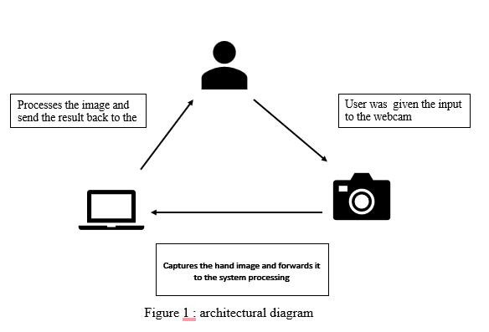
III.3. Data Collection and Preprocessing
Data collection for this system starts with continuously capturing video frames from the webcam using OpenCV cv2.VideoCapture() function which provides access to the live webcam feed. Each frame is passed through the Mediapipe Hand Tracking Model which identifies and processes 21 key landmarks on the user hand. These landmarks are the tips of the fingers and wrist and also include all joints in the finger. Thus a fine-resolution map of hand motion and location in space is maintained. The system takes these 2D coordinates as input scales them up by the webcam frame resolution to achieve the corresponding pixel positions which is then vital for the projection of user hand motion onto the screen. After extracting the landmark positions the system normalizes these values that ensure hand movements are proportionately scaled to screen resolution. In other words this pre processing is an important step because it guarantees working across diverse devices of varying screen sizes and resolutions. To add greater accuracy z-axis information may be added into the system that will enhance object tracking and make it easier to distinguish between objects nearer or farther away from the camera. This helps the system do precise gesture recognition even in mixed environments with diverse lighting levels for accuracy and consistency across different setups of users.

III.4. Hand Gesture Recognition
The system shall have the basis of functionality which would recognize a hand gesture by converting it to a computer operation. It relies on the recognition of relative locations of the key landmarks, there are 21 in total and are detected in a Mediapipe Hand Tracking Model. During this mode when no particular operation is done upon the user's hand, it then enters Neutral Mode wherein no operations are done as well. The most important gesture that the system recognizes is raising the thumb. The system starts tracking it as a scrolling gesture. It engages Scroll Mode when the vertical movement of the thumb is tracked and scrolls the content on the screen accordingly. Another important gesture is raising all five fingers, signaling the system to enter Cursor Control Mode. In this mode, the system traces the movement of the index finger to control the mouse cursor on the screen. Gesture recognition is designed to be fast and very accurate in the system, meaning that the system will respond with minimal delay from the user to the system in order to produce a seamless interaction experience for the users interacting with the system..

III.5 Gesture Recognition Process
The process of gesture recognition is initiated by detecting the user's hand and the landmarks associated with it. In the case of each gesture, the system looks at the relative positions of the key landmarks on the hand. For instance, when the user raises his or her thumb, the system determines that the thumb is elevated with respect to its base joint, which marks the beginning of a gesture. This gesture maps to an action such as scrolling. Similarly in case the index finger is raised the system takes that as a gesture for scrolling and follows the index finger movement in adjusting the content of the screen. It also detects more complex gestures like the "Click" gesture where the thumb touches the index finger to simulate a click on the mouse. In addition if the thumb and the middle finger touch each other the computer senses this as a "Drag" gesture and the user can drag selected items off the screen. These gestures are dynamically mapped to equivalent actions performed by the computer such as clicking, scrolling or dragging, allowing for easy and intuitive computer interface management. The system always monitors the landmarks and updates the interface according to the recognized gestures in real time thus allowing all interactions to be seamless

III .6. Action Execution
After the gesture is detected the system will use external libraries such as PyAutoGUI and Autopy to execute the corresponding action on the computer. For instance in Scroll Mode the system tracks the vertical movement of the thumb and uses PyAutoGUI to scroll the content up or down based on the direction and distance of the thumb's motion. The scrolling speed may be adjusted dynamically based on the movement of the thumb for fine grained control over the scrolling behaviour. Mapping the position of the index finger to the screen coordinates using Autopy allows cursor control mode to make the mouse cursor traverse smoothly and precisely as the user moves their finger. When the thumb touches the fore finger the system simulates the mouse click operation and a "Drag" gesture allows for the simulation of dragging operations performed on the computer screen. Real time execution occurs ensuring interaction with the computer without perceptible delay for the user a very responsive system.

III.7. Real-Time Processing and Mode Switching
The system is in real time it captures every video frame from the webcam. This makes sure that any gestures made by the user are translated into action as soon as they are performed with a minimum amount of latency between input and response. Real time processing is essential for the smoothness and fluidity of the user experience with the system reacting instantaneously to every gesture. Among other characteristics, this system can easily change modes from the detected gestures. For instance when it recognizes that the index finger is being raised the system enters Scroll Mode. Similarly a lift of all the five fingers brings the system into Cursor Control Mode. This ability to dynamically switch between modes allows a user to control various functions such as scrolling, cursor movement, and clicking of the mouse with a simple gesture. So the system is designed to make this switching as easy and preferably seamless as possible to ensure interruption or delay in tasks is avoided.

III.8. User feedback and response
Clear and timely feedback from the users is necessary in order to allow for smooth, intuitive interaction with the system. The system furnishes the user with real-time visual feedback of which mode it is currently operating in. As an example, when the system is in Scroll Mode, "Scroll" displays on the screen, and "Cursor" will be displayed while the user controls the mouse pointer. This feedback, therefore, ensures that the system correctly identifies the gesture and performs the action for which the user is waiting. In case it loses the user's hand temporarily, the system automatically shifts to Neutral Mode and keeps on scanning for the hand in subsequent frames without creating a lot of hassle. This would ensure a very smooth experience in case the system loses track momentarily sometimes.

III.9. Error Handling:
As part of error handling, the system does not stall in worse-than-average conditions; it will continue to be reliable and responsive. If the system is unable to track the hand or if the hand cannot be located, it will default to Neutral Mode and search for the hand again in the next frames of video. This way the system will not freeze or become unresponsive even when the hand is momentarily out of view or moved too fast. It is designed such that it will automatically recover from tracking errors due to continuous search for the hand and reinitiate the gesture detection process when the hand reappears within the frame. This continuous error recovery ensures that the system remains usable and responsive even under challenging conditions.

III.10.Optimization Considerations
There are many optimization strategies adopted to ensure the system performs at its best, without placing undue strain on system resources. For instance, reducing the resolution of a webcam feed or the number of frames processed per second reduces the load on the CPU and, therefore, enhances the overall performance of the system. When it is not necessary to have high frame rates, these optimizations can save computational resources without giving up much in functionality. Latency is another key optimization: Latency is important so that gestures can be translated to actions without the perception of latency. Lighting can also play an important role. While the system is quite robust in its handling of multiple lighting conditions, good lighting makes all the difference between proper hand tracking under low lighting conditions and an inaccurate, potentially unreliable, track.

III.11. User and Performance Testing
To make sure it functions successfully under a range of real-world circumstances the system is put through a thorough testing process. As part of this testing the accuracy of the system is assessed in various hand sizes, gestures, and settings. To make sure the system is accurate and responsive on a variety of devices performance is also evaluated in a range of lighting scenarios, resolutions and frame rates. Additionally there is user testing which is done to get input from actual users so that the system can be adjusted and optimized to accommodate a variety of user demands and preferences. These tests ensure that the system functions properly and efficiently on any device or in any environment.

III.12. Testing for Environment and Lighting
To make that the system can function in a variety of lighting conditions including well-lit rooms and low light settings it is finally tested in other lighting scenarios. Hand tracking accuracy greatly increases in well-lit areas, even though the Mediapipe framework is made to function effectively in a variety of lighting scenarios. To make sure it can recognize the right hand gestures while disregarding any irrelevant factors, the system is tested under a variety of illumination scenarios that simulate real-world usage.

IV.Basic Block Diagram
The cursor position is updated in real time based on the detected hand movements. The block diagram of the hand gesture control system will show how the program works step by step in Figure 2 Basic Block Diagram of the System. First, the Camera/Webcam captures the video of the user's hand movements. Then, the Hand Detection part makes use of a tool called MediaPipe to determine the positions of the hand's key points Finally the Landmark Position Detection acquires the exact location of those points.

Figure 2: Basic Block Diagram of the System

The Gesture Recognition section determines which gesture the user is performing example a finger up to scroll, all fingers up to move the cursor. The system then moves to the Cursor or Scroll Actions section, where it controls the mouse on the screen by moving the cursor or scrolling. The Display Mode Feedback displays which mode is active-Cursor or Scroll. The system continues running and detecting gestures, repeating the process until the user stops it.

V . Implementation Result
The system was implemented using Python with the OpenCV library for image processing and tensor flow to implement the machine learning model for hand gesture recognition. It is fine tuned to the specific gesture used to control the cursor. The Customization Page enables users to configure the gesture control system based on their needs(Figure 3. the start and customization page of the project ). It allows them to modify cursor sensitivity horizontally along the X axis and vertically along the Y axis to make smooth and accurate control match the size of their display and workspace.

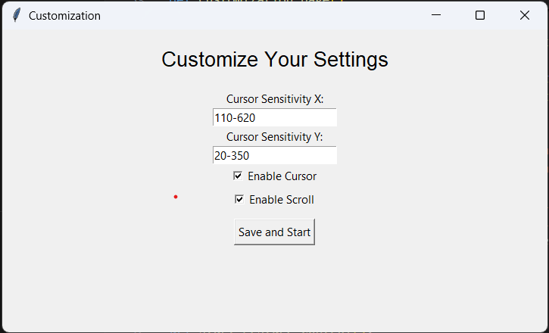
Figure 3 : the start and customization page of the project

In addition users may choose to disable or enable features like cursor control (figure.4.1 and figure 4.2 cursor control) and scroll gestures(figure.4.3 and figure 4.4 scroll control) depending on the need. Users can then save their settings which will be immediately applied the next time the gesture control system starts. The page allows for flexibility, thus making the entire system very user friendly as it customizes the system according to the user preferences

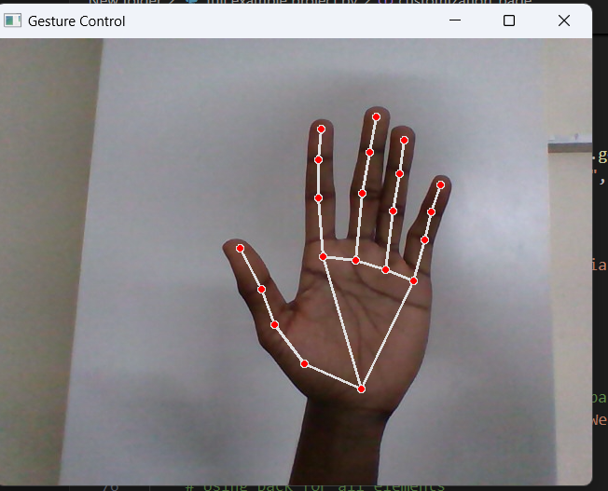

Figure 4.1 : Cursor Move Control
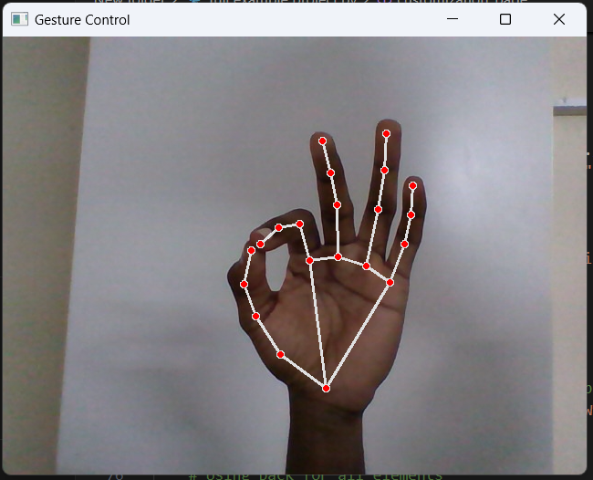

Figure 4.2 : Cursor Click Control
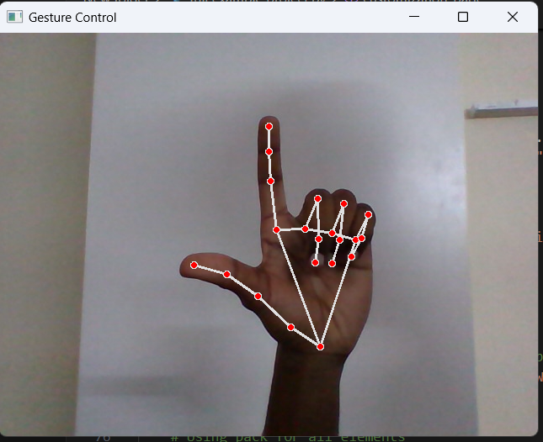

Figure 4.3 : Scroll Control (Upward)
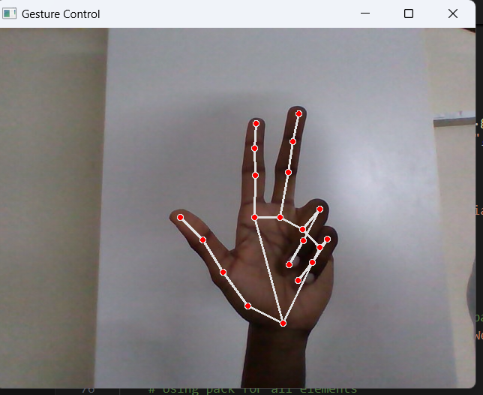

Figure 4.4 : Scroll control (Downward)

The Cursor Control feature will enable users to control their mouse cursor with hand. It will provide a more intuitive and touchless manner in which users can work with their computer. Using the movement of the index finger the system transforms the position into cursor movement on the screen. Thus this feature allows smooth navigation with sensitivity settings customized according to the user's workspace and monitor size. In addition, more complex gestures, such as combining positions of fingers, can evoke mouse actions, like left click, right click or dragging. The Cursor Control feature is suitable for hands free operation and enhances accessibility making it an important part of the gesture control system
A user study was conducted to evaluate the usability and accuracy of the system. Participants were asked to perform multiple tasks such as pointing, scrolling, dragging, and clicking using only hand gestures.

We measured the following metrics:

- Accuracy: Percentage of correct gesture classifications.
- Latency: The time taken from gesture recognition to cursor movement.
- User Experience: Participants feedback on ease of using and comfort.

Graph Comparison
The results from the Figure 8 comparison graph for proposed & Exiting system illustrate that your hand gesture based cursor control project has done better than another similar project in key areas. our project on the whole shows more accuracy at 93.5% versus 89.8% indicating it detects gestures more efficiently. Another aspect is that your project shows more precision at 92% versus 88% and recall at 91% versus 87% thus making fewer errors and detecting more correct gestures. The F1 score which balances precision and recall is higher at 91.5% compared to 87.5%. Additionally your project shows a lower false positive rate 7% instead of 10% and a lower false negative rate 9% compared to 12% meaning fewer errors. To summarize your project demonstrates higher effectiveness in the correct and reliable detection of hand gestures.

VI. Future Developments
There are a few key areas of further improvement in this project, which include the accuracy, speed and flexibility of customization. The system can be increased in precision to a great extent by incorporating more complex algorithms for machine learning and complex feature extraction. This would make it less prone to errors and highly dependable. The algorithms existing could be optimized to run in high frame rate cameras to optimize real time performance. This will ensure smooth and faster movements of cursors with almost no latency. The system is going to support user configurability aspects like the definition of gestures customized to a user preference and allow the sensitivities to vary with changes in the condition and lighting to provide improved performance irrespective of the prevailing lighting. These developments will then ensure an improvement in all areas from the perspective of technology development

VII.Conclusion
The Enhanced Accuracy and Customization in Hand Gesture Cursor Control Using Python and OpenCV has made interaction with computers more intuitive and natural as we can achieve computing systems through natural movements of the hand, which is also a movement based approach on a cursor. Computer vision and machine learning make it possible for hand tracking systems to precisely monitor the movement and use it as a cursor controlling method. This technology seems to fit very well in terms of augmenting accessibility improving usability and enabling alternative means of interaction for people with mobility issues. These systems will be enhanced further in terms of precision, velocity and user customization which will make these systems stronger and easier to operation. In the end, the technology of gesture recognition has the capability to change how we interact with digital systems and open to viewers a new era where touchless and intuitive controls are standard.

VIII. Reference

- H. Li, L. Li, and D. H. Kim, "Hand Gesture Recognition for HCI: A Survey," J. HCI, vol. 2022, 2022.
- T. Shahid, T. Imran, and M. S. Khan, "Real-Time Gesture Recognition for Computer Interface Control," Int. J. Compu. Vis. Appl., vol. 2021, 2021.
- V. Jain and R. Gupta, "Machine Learning Techniques for Hand Gesture Recognition: A Comparative Review," Int. J. Compu. Appl., vol. 2021, 2021.
- Y. Kim and J. Choi, "Gesture Recognition Using Convolutional Neural Networks for Cursor Control," IEEE Trans. Clyburn, vol. 2020, 2020.
- J. Zhang and W. Xu, "Hand Detection and Gesture Recognition Based on Computer Vision," Int. J. Image Process., vol. 2021, 2021.
- Riaz and F. Ahmed, "Real-Time Hand Tracking and Gesture Recognition for Cursor Control Using Webcam," J. Compu. Vis. Appl., vol. 2020, 2020.
- L. Wang and F. Liu, "The Role of Gesture Recognition in Enhancing User Experience in Gaming and Virtual Reality," Compu. Hum. Behav., vol. 2020, 2020.
- S. Ahmed and N. Siddique, "Gesture-Based Interaction for Accessibility in Computing Devices," Universal Access in the Inf. Soc., vol. 2020, 2020.
- Y. Zhang and Z. Chen, "Challenges in Gesture Recognition: Environmental and Algorithmic Factors," J. Real-Time Syst., vol. 2019, 2019.
- R. Kumar and M. Vatsa, "Performance Evaluation of Gesture Recognition Systems for Cursor Control in Dynamic Environments," Int. J. Compu., vol. 2021, 2021.
- C. Chao and Y. Han, "User Study on Hand Gesture Control for Cursor Movement: Evaluating Usability and Accuracy," J. HCI, vol. 2021, 2021.
- S. Soni and S. Gupta, "A User-Centered Approach to Gesture-Based Cursor Control: Feedback and Usability Evaluation," Int. J. Hum.-Compu. Interact., vol. 2022, 2022.
- Dey and V. Patel, "A Comprehensive Review on Real-Time Gesture Recognition Systems for Cursor Control," IET Image Process., vol. 2020, 2020.
- M. Bhatti and A. Rehman, "Hand Gesture Recognition Using Webcam and Deep Learning Algorithms for Accessibility Applications," in Springer Handbook of Human-Computer Interaction, 2022.
- A. Alnuaim et al., "Human-computer interaction with hand gesture recognition using ResNet and MobileNet," Computational Intelligence and Neuroscience, vol. 2022, 2022.
- J. Alyami et al., "Tumor localization and classification from MRI of brain using deep convolution neural network and Salp Swarm Algorithm," Cognitive Computation, vol. 2023, 2023.
- M. A. R. Azim, A. Rahman, and S. Heo, "SequenceSense: A tool for designing usable foot-based gestures using a sequence-based gesture recognizer," Int. J. Hum.-Compu. Stud., vol. 2023, 2023.
- R. Bainbridge and J. A. Paradiso, "Wireless hand gesture capture through wearable passive tag sensing," in Proceedings of IEEE, 2011.
- A. A. Barbhuiya, R. K. Karsh, and R. Jain, "CNN-based feature extraction and classification for sign language," Multimedia Tools and Applications, vol. 2021, 2021.
- H. Baumgartl et al., "Vision-based hand gesture recognition for human-computer interaction using MobileNetV2," in Proceedings of the 2021 IEEE 45th Annual Computers, Software, and Applications Conference, 2021

KAMALANABAN E  Vel Tech High Tech Dr.Rangarajan Dr.Sakunthala Engineering College,  Chennai,India | V.SABAPATHI  Vel Tech High Tech Dr.Rangarajan Dr.Sakunthala Engineering College,  Chennai,India  , | NAVEEN N  Vel Tech High Tech Dr.Rangarajan Dr.Sakunthala Engineering College,  Chennai,India  naveennagarajan751@gmail.com | LATHISH P  Vel Tech High Tech Dr.Rangarajan Dr.Sakunthala Engineering College,Chennai,India  lathishcse@gmail.com | NIHITHA T  Vel Tech High Tech Dr.Rangarajan Dr.Sakunthala Engineering College,  Chennai,India  nihitha0406@gmail.com

